Designing Visually Appealing Certificate for a debate competition using canva

**Project Description**

The "Crafting Visually Striking Certificates for a Debate Competition using Canva" project focuses on creating impressive and memorable certificates to recognize the participants, winners, and contributors of a debate competition. A well-designed certificate not only serves as a token of achievement but also reinforces the prestige and professionalism of the event. N **Purpose**

The "Crafting Visually Striking Certificates for a Debate Competition using Canva" project focuses on creating impressive and memorable certificates to recognize the participants, winners, and contributors of a debate competition. M **Problem Definition And Design Thinking Empathy Map**

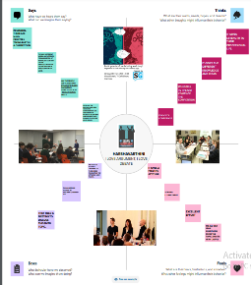 **Ideation And Brianstroming Map**

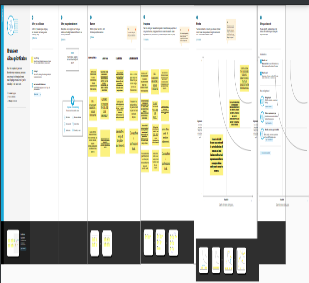 **Result** 